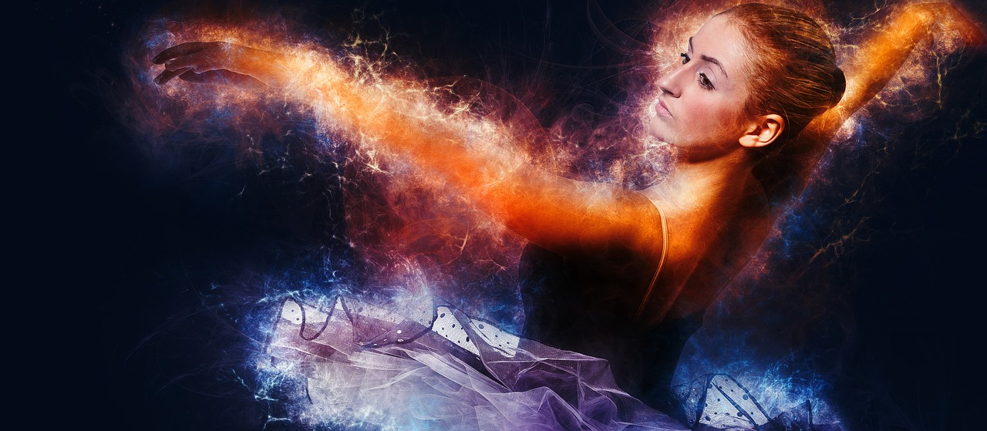

First Fruits First Lover of my Soul September 1, 2019

This morning I tuned in to Paul Wilbur’s song “Dance with Me.” I’m including the link if you are so moved: https://www.youtube.com/watch?v=75vPy71e-6Q

There are moments of revelation in this life that change us. And there’s a book in scripture that speaks to our hearts as the Bride of Yeshua. The Song of Solomon voices a love that we have dreamed of.

How can it be that such love is true? How do we put into the words the hopes of the heart? How do we express the inexpressible realization that someone would lay down His life for us? Words fail.

Over the last week I’ve been sitting with a verse: “But the Lord was pleased to crush Him, putting Him to grief.” [Isaiah 53:10]

This kind of love stretches us. Sacrifice is the truest test of love. Letting go of something so valuable that we would give up our lives that others would live.

I have to ask you, “Is this the One who you would dance with?” Our Father is asking you to come and dance with the Lover of my Soul. That’s an invitation that can’t be refused.

The One who sacrificed the most, the Firstfruits of Creation, the King of the Universe, the Light of the World, the Crushed and Resurrected Lord has instructed His Heavenly Hosts to play His music and to sing His lyrics over you as He takes the hand of His Beloved.

All Creation is hushed as the dance floor clears. The music begins. His Ruach Released!

Let the Sound of His Majestic Glory capture your imagination as you are swept off your feet by a compassionate loving Savior. “In His Presence is Fullness of Joy.” [Psalm 16:11]

Harken your Heart! Dance, dance, dance with the Lover of my Soul!

